ESG Survey Automation

Contents

Introduction (Business Need): 2

Challenge Description: 2

Tasks 2

Implementation Logic 2

User Interface 3

Prerequisites:- 3

User Stories 3

Deliverables 4

Expected Solution 4

Solution Package: 4

Design Approach 4

Working code 4

Playbook 5

Automated Test Suite and Coverage Report 5

Required Results 5

Sample Report for one questionnaire: 5

Comprehensive & Brief information 6

FAQs: 6

Reports 6

# Introduction (Business Need):

Environmental, Social, and governance (ESG) considerations continue to transform today’s financial landscape. Stakeholders increasingly expect a company’s business strategy to align with its climate and equity commitments. While companies are at various stages on their sustainability journey, they must drive accountability today for a sustainable tomorrow. Several third-party organizations and agencies request large, public companies to complete ESG surveys, which assess company performance on ESG and Sustainability related topics and produce scores for related performance areas. These scores are commonly interpreted by investors to understand how well a company is performing from an ESG perspective. As such, company performance scores and ratings carry business implications.

Currently, our Enterprise Sustainability Team responds to surveys by interpreting various publicly available disclosures and documentation to respond to external ESG surveys (Examples include : S&P Global CSA, Eco Vadis, ISS E&S data validation, MSCI ICP, MSCI Climate One, CDP, and JUST Capital). The team invests a significant amount of time in the process of collecting information pertaining to each survey from several public sources, including sustainability reports, which include both quantitative and qualitative information. This information is collected to respond to relevant questions in the survey, which must include specific text, page / document references, and related evidence supporting the answer for audit purposes.

# Challenge Description:

Design an innovative solution to respond to survey questions by retrieving responses and relevant information from public, our -owned disclosures, such as PDF-files and web-pages by using cutting-edge technologies. Additionally, develop automated solution for recording references and citations from related sources (e.g., document link, page number, paragraph/data) which address each question in the survey. The goal is to develop a robust, automated information collection system capable of parsing complex reports related to various categories concerning the ESG and other business documents to extract relevant data based on Survey Questionnaire related to the company.

If time permits additional scope includes scrapping information available from internet as part of publicly accessible information about us.

# Tasks

## Implementation Logic

1. **PDF, Excel Parsing**

- Implement the logic to fetch the details of questionnaire “**ESG_Reporting_Questionnaire.pdf**” and parse the input details from PDF and generate the report similar to “**ESG_Reporting_Response.pdf**” and “**ESG_Reporting_Climate_Change_Responses.pdf**”

- Implement a script/ trained model to extract relevant questionnaire from web pages or PDF documents.

2. **NLP for Context Understanding:**

- Integrate NLP libraries such as spacy or NLTK to process and understand the context of the extracted text or suitable LLM models.

- Implement algorithms to identify key entities, relationships, and sentiment within the text. This step is crucial for extracting meaningful insights from the parsed question.

3. **Gathering Questionnaire Inferences:**

- Establish connections to ESG and Sustainability Report /external publicly disclosed company sources (e.g., APIs or databases) to fetch reporting information from designated documentation (S & G, DEI, TCFD).

- Develop functions to retrieve and organize data relevant to the entities being analyzed.

4. **Report Generation with Ratings:**

- Implement a report that generates best referential Data (Document/Page/Paragraph) based on the closest match based on accuracy and a short, summarized answer.

## User Interface

1. Use chainlit or similar user interface which allows bank analyst to upload excel questionnaire and supporting documents in PDF as input and generate the report along with generative AI based report
2. If time permits have Q & A chatbot which retrieves information from uploaded PDF

# Prerequisites:-

1. **Sample data** – Please refer to report section for more details about the sample

2. **Access to ML tools like Azure ML studio or Google Vertex**

# User Stories

1. Input 1: As an **ESG Analyst**, I want a tool to upload the PDF’s related ESG and Sustainability reports.
2. Input 2: As an **ESG Analyst,** I want to upload PDF/Spreadsheet Survey Questionnaire based on which a detail reporting needs to be generated.
3. Input 3: As an **ESG Analyst,** I want to upload a Question based on which a detail reporting needs to be generated.

**Result:** Answer with citation/scoring for the uploaded Question.

1. Tool which generates and returns the survey answers/details and a generative based AI which explains how/where the corresponding answer details are referred from(citation information).

# Deliverables

## Expected Solution

1. Develop the AI based model available in VDI (or) Azure which identifies and retrieves the required information from PDF, Webpages based on questionnaire uploaded. You can use chatbot library like Chainlit (or) develop the web portal too which helps bank analyst to perform effectively
2. Components should be modularized and exposed as API for seamless testing with authentication, This is needed even though you have user interface
3. Final Deliverables should have following artifacts
   * GIT repository without any compilations issues
   * Readme to start the application along with concise documentation which explains the core components, model, accuracy and design decisions
   * Record the working demo and store in Google Drive or GIT
   * Credentials to login to application
   * Postman collection for exposed API with authentication headers as place holders
   * Unit test cases
4. Modules should be well tested with test data provided in “sample data” folder and required
5. Based on available time, try to implement innovative solutions like chain of thoughts, train the model from user interface based on authorization, Github actions for auto deploy and strong security layer, leverage vector DB for contextual search and embeddings, interactive chatbot functionality to query the details

## Solution Package:

Following are the tasks that need to be executed as part of this challenge:

* Provide high level user stories for the challenge.
* Provide a Design approach.
* Code that needs to be uploaded to the GIT repo (Instructions for Git).
* Provide playbook.
* Automated test suite and coverage report.

Details of each of the deliverables are as follows:

## Design Approach

The design document should detail out overall approach on solving the problem. This could include any class diagrams/sequence diagrams indicating the approach and a high level traceability matrix.

## Working code

The resultant application should have good quality and generic enough so that new rules can be added and/or removed easily and committed to respective Git repos that are assigned.

## Playbook

Provide Playbook/Runbook for deploying the solution. Provide information towards how it should be deployed & monitored.

## Automated Test Suite and Coverage Report

Test cases for various edge cases should be automated. Application needs to be tested as per the test cases and the results need to be captured along with the coverage report and any excel report and graphs.

## Required Results

## Sample Response for one question:

**Question Serial No:** 09-e

**Theme:** Labor & Human Rights

**Impact and Score:** High

**Parent Question:** What actions are in place regarding training and career management?

**Response selection:** Provision of skills development training

**Enter "yes" for options applicable to your company; otherwise leave as blank :** Yes

**Guidance from survey:**

The document(s) should demonstrate the following: training programs provided to employees to strengthen their knowledge and skills specific for their work or for their career advancement. Examples of documents to attach: training materials and additional evidence of training execution (progress reports, certificates of completion, etc.), Annual Report, CSR/Sustainability Report, etc.

**Relevant WF publications and links**

1. 2023 DEI Report: <https://www.wellsfargo.com/assets/pdf/about/corporate/diversity-equity-inclusion-report.pdf>
2. 2022 S&G Report: <https://www.wellsfargo.com/assets/pdf/about/corporate-responsibility/sustainability-and-governance-report.pdf>

**References in Documents (specific text / evidence extracted from above publications)**

2023 DEI Report p. 13

Career Development Framework

- In 2022, we launched our Career Development

Framework which provides a holistic framework for employees to manage their careers, including skills assessment, development action plans, training/skills development, and manager support. Additionally, we are providing manager development that includes resources for managers to support employee career development.

2022 S&G Report - p.47

Training and development

We support, encourages, and substantially invests in employee and manager training and development. In 2022, our training and development investment was approximately $200 million, spanning an array of functional training, regulatory compliance, leadership, and early career development programs for employees. Our Learning and Development team is focused on training employees “wherever they work” by extending our virtual training sessions instituted during the COVID-19 pandemic. Our Learning and Development efforts earned four industry awards recognizing the achievements in technology innovation, supporting change transformation, corporate university strategy, and diversity, equity, and inclusion training"

Sample API Request:

{

"reportYear": "2024",

“InputQuestion”:”What is the annual profit of the company excluding the capital expediture and Report to be generated in the format per year”

}

Sample API Response:

{

"reportYear": "2024",

"**questionnaireSummary**":

{

“**response**”:”Information available publicly

---FY 2019: $5,010,000

---FY 2020: $4,430,000

---FY 2021: $3,830,000

---FY 2022: $4,010,000”,

"status": "success",

"**citation**": "→ Lobbying, interest representation or similar 2019-2021: 2021 ESG Report - p. 47 (Spending on federal lobbying activities metrics)

https://www.wellsfargo.com/assets/pdf/about/corporate-responsibility/environmental-social-governance-report.pdf

FY19: 5,010,000

→ Lobbying, interest representation or similar 2022: 2022 S&G Report - p. 58 (Spending on federal lobbying activities metrics)

https://www.wellsfargo.com/assets/pdf/about/corporate-responsibility/sustainability-and-governance-report.pdf

FY20: 4,430,000

FY21: 3,830,000

FY22: 4,010,000

→ Local, regional or national poltical campaigns / organizations / candidates: 2021 ESG Report - p. 47 (Corporate PAC contributions metrics)

https://www.wellsfargo.com/assets/pdf/about/corporate-responsibility/environmental-social-governance-report.pdf

FY19: 763,250

→ Local, regional or national poltical campaigns / organizations / candidates: 2022 S&G Report - p. 58 (Corproate PAC contributions metrics)

https://www.wellsfargo.com/assets/pdf/about/corporate-responsibility/sustainability-and-governance-report.pdf

FY20: 1,010,750

FY21: 741,700

FY22: 1,670,350

→ Other (e.g. spending related to ballot measures or referendum): 2019 ballot measure spending - p.1 (document title)

https://www08.wellsfargomedia.com/assets/pdf/about/corporate-responsibility/2019-ballot-measures.pdf",

"**documentReference**":"https://www.wellsfargo.com/assets/pdf/about/corporate-responsibility/environmental-social-governance-report.pdf, https://www.wellsfargo.com/assets/pdf/about/corporate-responsibility/environmental-social-governance-report.pdf"

"**accuracy**": "0.8",

"**confidenceScores**": "0.8"

}

}

## Comprehensive & Brief information

The results should have following information

* Referential Document Information (name and hyper-link)
* Referential Justification Information prevailing in the document with details of Section/Page/Paragraph for evidence purposes.

# FAQs:

Please note: We recommend you to refer to the common FAQs provided for the main challenge.

#### Artifacts to be uploaded

Below mentioned artifacts and code to be uploaded to Git repository following the instructions below. **It is mandatory to adhere to these instructions to be eligible for evaluation.**

* Git repo has the following folder structure.
  + **Artifacts** 
    - **demo_presentation**
    - **design**
    - **playbook**
    - **test_results**
  + **Code**
* **Git folder structure**

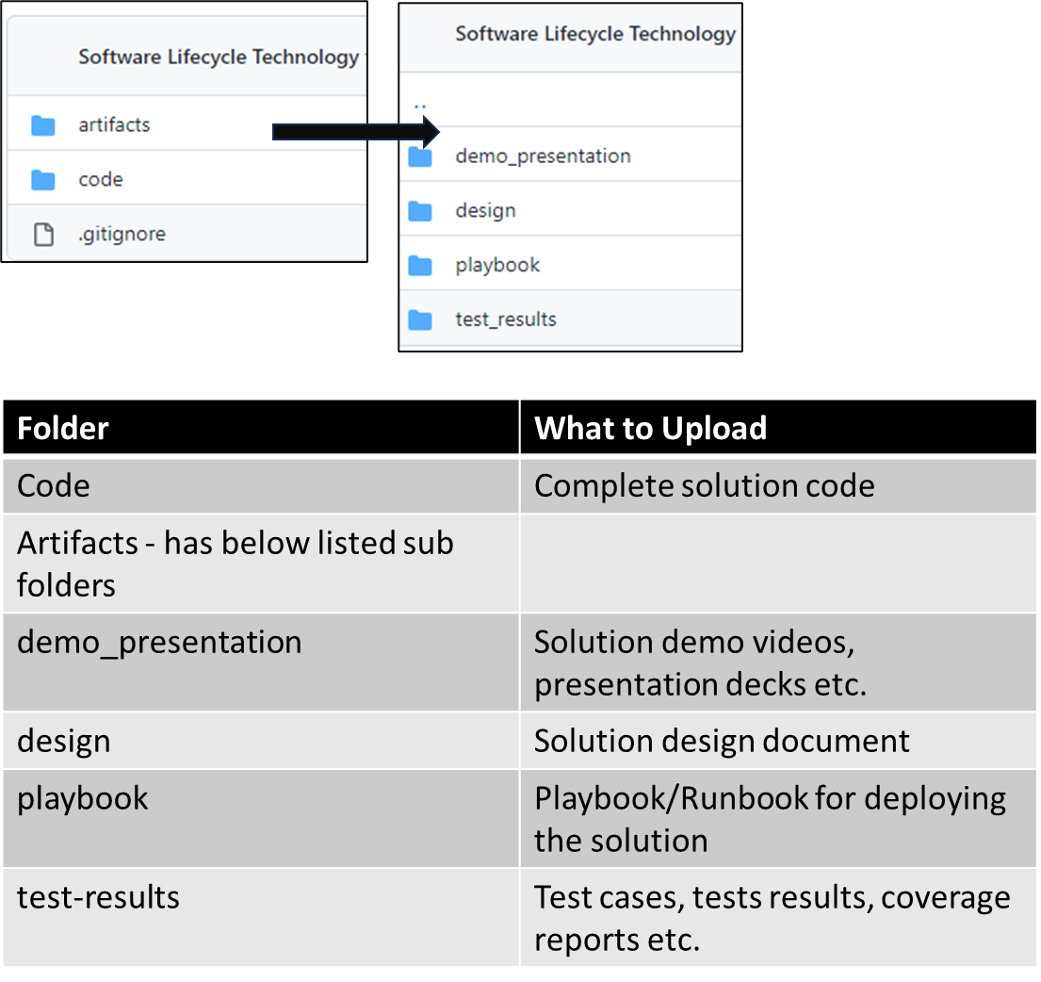

# Evaluation Approach:

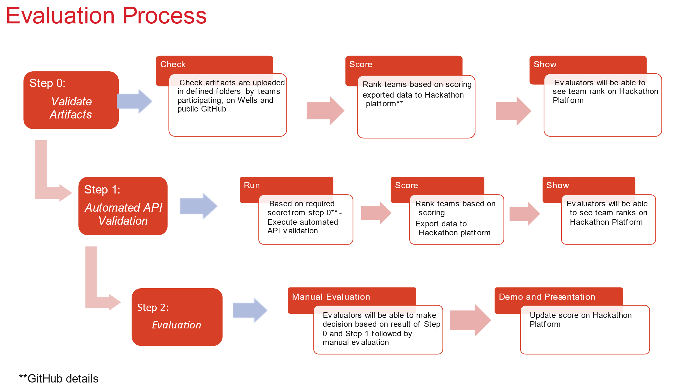

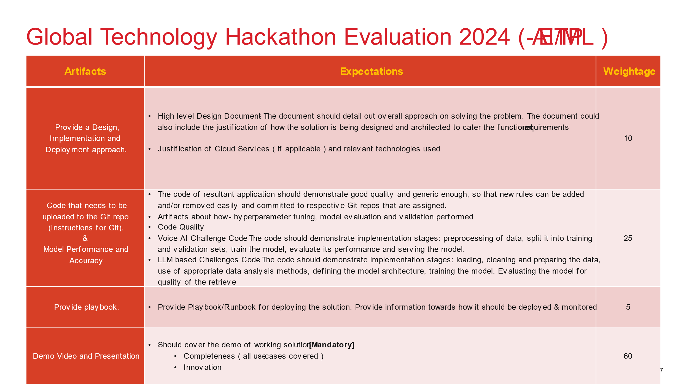

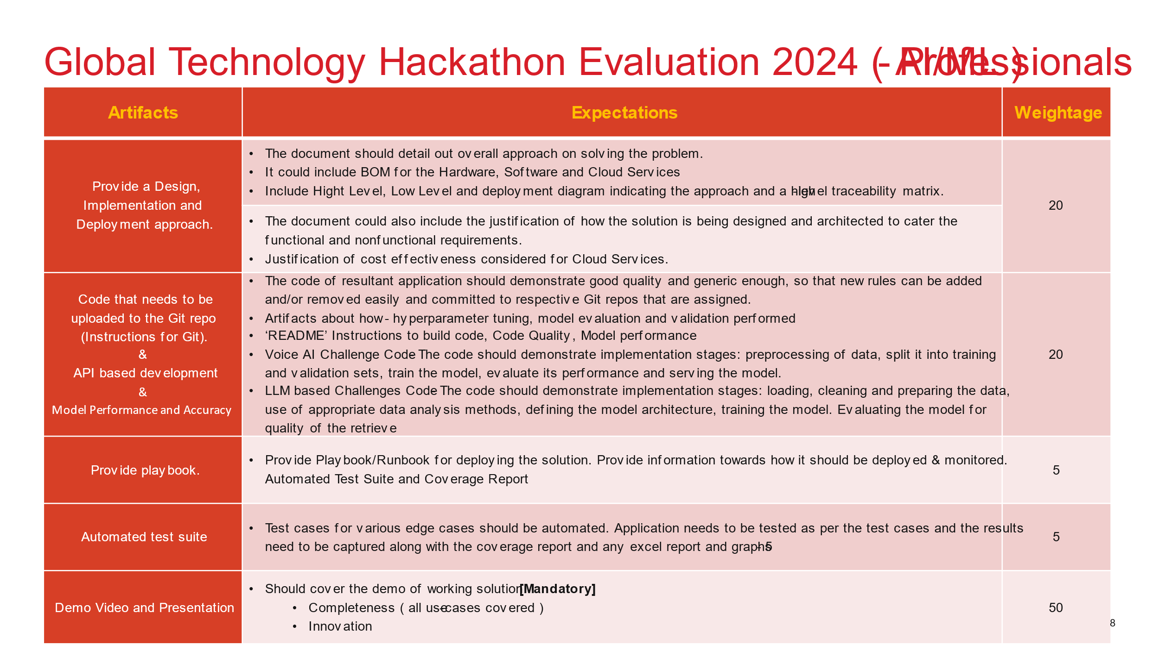

# Reports

[Goals and Reporting – Corporate Social Responsibility –](https://www.wellsfargo.com/about/corporate-responsibility/goals-and-reporting/)

* Recent ESG reports and financed emissions disclosures
* [Sustainability and Governance Report (PDF)](https://www.wellsfargo.com/assets/pdf/about/corporate-responsibility/sustainability-and-governance-report.pdf)
* [Diversity, Equity, and Inclusion Report (PDF)](https://www.wellsfargo.com/assets/pdf/about/corporate/diversity-equity-inclusion-report.pdf)
* [Statement of Greenhouse Gas Emissions (PDF)](https://www.wellsfargo.com/assets/pdf/about/corporate-responsibility/statement-greenhouse-gas-emissions.pdf)
* [Task Force on Climate-related Financial Disclosures (TCFD) report (PDF)](https://www.wellsfargo.com/assets/pdf/about/corporate-responsibility/climate-disclosure.pdf)
* [CO2eMissionSM methodology and subsequent disclosures](https://sites.wf.com/co2emission)